**AIM: Write program to obtain the Topological ordering of vertices in a given digraph.**

#include<stdio.h>

int temp[10],k=0;

void topo(int n,int indegree[10],int a[10][10])

{

int i,j;

for(i=1;i<=n;i++)

{

if(indegree[i]==0)

{

indegree[i]=1;

temp[++k]=i;

for(j=1;j<=n;j++)

{

if(a[i][j]==1&&indegree[j]!=-1)

indegree[j]--;

}

i=0;

}

}

}

void main()

{

int i,j,n,indegree[10],a[10][10];

printf("enter the number of vertices:");

scanf("%d",&n);

for(i=1;i<=n;i++)

indegree[i]=0;

printf("\n enter the adjacency matrix\n");

for(i=1;i<=n;i++)

for(j=1;j<=n;j++)

{

scanf("%d",&a[i][j]);

if(a[i][j]==1)

indegree[j]++;

}

topo(n,indegree,a);

if(k!=n)

printf("topological ordering is not possible\n");

else

{

printf("\n topological ordering is :\n");

for(i=1;i<=k;i++)

printf("v%d\t",temp[i]);

}

}

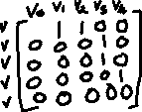

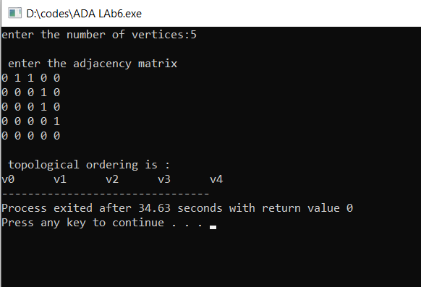

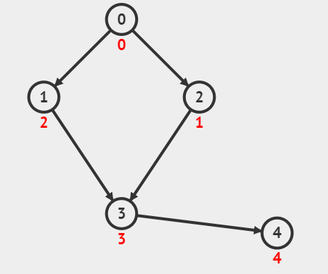

0 1 1 0 0 0 0 0 0 0 0

0 0 0 1 0 0 0 0 0 0 0

0 0 0 0 0 0 0 0 0 0 0

0 0 0 0 1 0 0 0 0 0 0

0 0 0 0 0 0 0 0 0 0 0

0 0 0 1 0 0 0 0 0 0 0

0 0 1 0 0 0 0 0 0 0 0

0 0 0 0 0 0 1 0 0 0 0

0 0 0 0 0 0 1 0 0 0 0

0 0 1 0 0 0 0 0 1 0 1

0 0 0 0 0 0 0 0 0 0 0

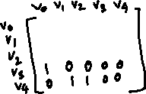

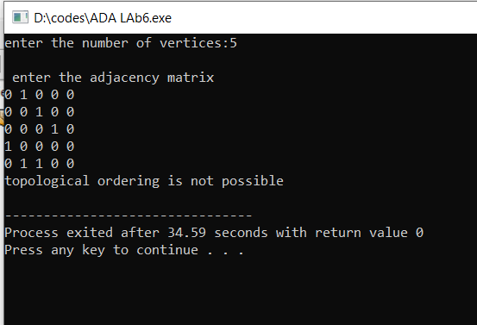

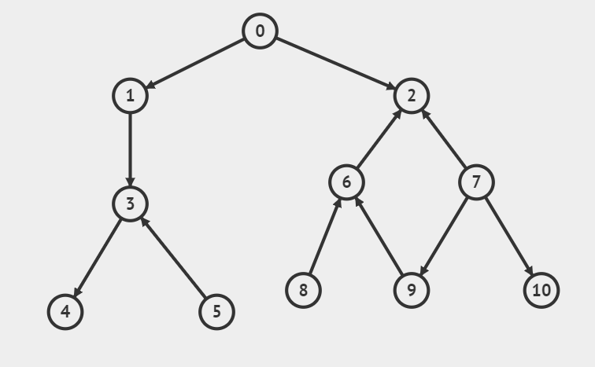

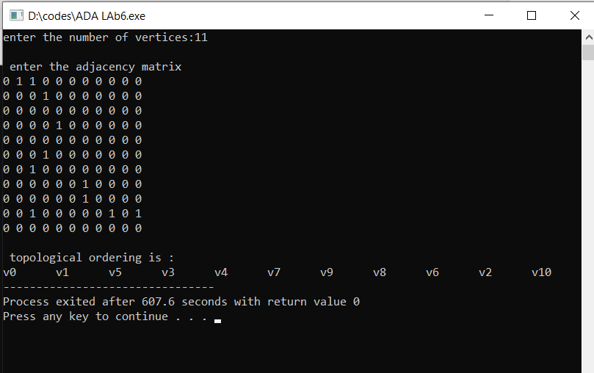

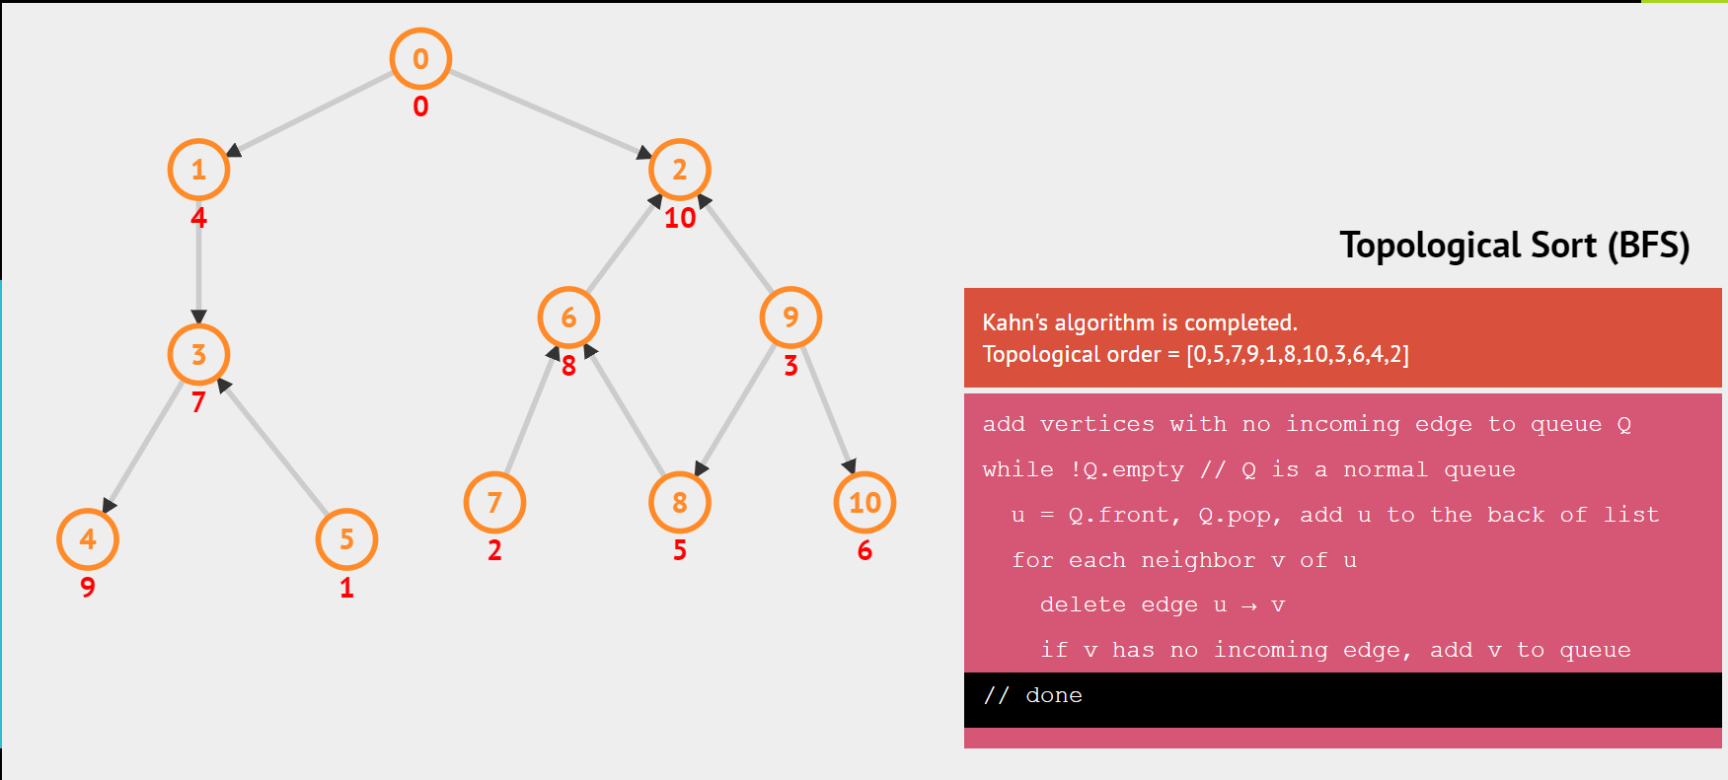

**Using DFS Technique**

#include<stdio.h>

int res[10],top=0,s[10];

void dfs(int v,int n,int a[10][10]){

s[v]=1;

for(int i=1;i<=n;i++)

if(s[i]==0&&a[v][i]==1) dfs(i,n,a);

top++;

res[top]=v;

}

void topo(int n,int a[10][10])

{

for(int i=1;i<=n;i++){

s[i]=0;

}

top=0;

for(int i=1;i<=n;i++){

if(s[i]==0)dfs(i,n,a);

}

}

void main()

{

int i,j,n,vertices[10],a[10][10];

printf("enter the number of vertices:");

scanf("%d",&n);

for(i=1;i<=n;i++)

vertices[i]=0;

printf("\n enter the adjacency matrix\n");

for(i=1;i<=n;i++)

for(j=1;j<=n;j++)

{

scanf("%d",&a[i][j]);

}

topo(n,a);

if(top!=n)

printf("topological ordering is not possible\n");

else

{

printf("\n topological ordering is :\n");

for(int i=n;i>0;i--){

printf("v%d\t",res[i]);

}

}

}

